Spring Core and Maven

Exercise 1: Configuring a basic Spring Application

Pom.xml:

<project xmlns="http://maven.apache.org/POM/4.0.0"  
 xmlns:xsi="http://www.w3.org/2001/XMLSchema-instance"  
 xsi:schemaLocation="http://maven.apache.org/POM/4.0.0  
 http://maven.apache.org/xsd/maven-4.0.0.xsd">  
 <modelVersion>4.0.0</modelVersion>  
 <groupId>com.example</groupId>  
 <artifactId>SpringCore_Maven</artifactId>  
 <version>1.0-SNAPSHOT</version>  
  
 <properties>  
 <java.version>1.8</java.version>  
 <spring.version>5.3.30</spring.version>  
 </properties>  
  
 <dependencies>  
 <dependency>  
 <groupId>org.springframework</groupId>  
 <artifactId>spring-context</artifactId>  
 <version>${spring.version}</version>  
 </dependency>  
  
 <dependency>  
 <groupId>org.springframework</groupId>  
 <artifactId>spring-beans</artifactId>  
 <version>${spring.version}</version>  
 </dependency>  
  
 <dependency>  
 <groupId>org.springframework</groupId>  
 <artifactId>spring-core</artifactId>  
 <version>${spring.version}</version>  
 </dependency>  
  
 <dependency>  
 <groupId>org.springframework</groupId>  
 <artifactId>spring-expression</artifactId>  
 <version>${spring.version}</version>  
 </dependency>  
 </dependencies>  
</project>

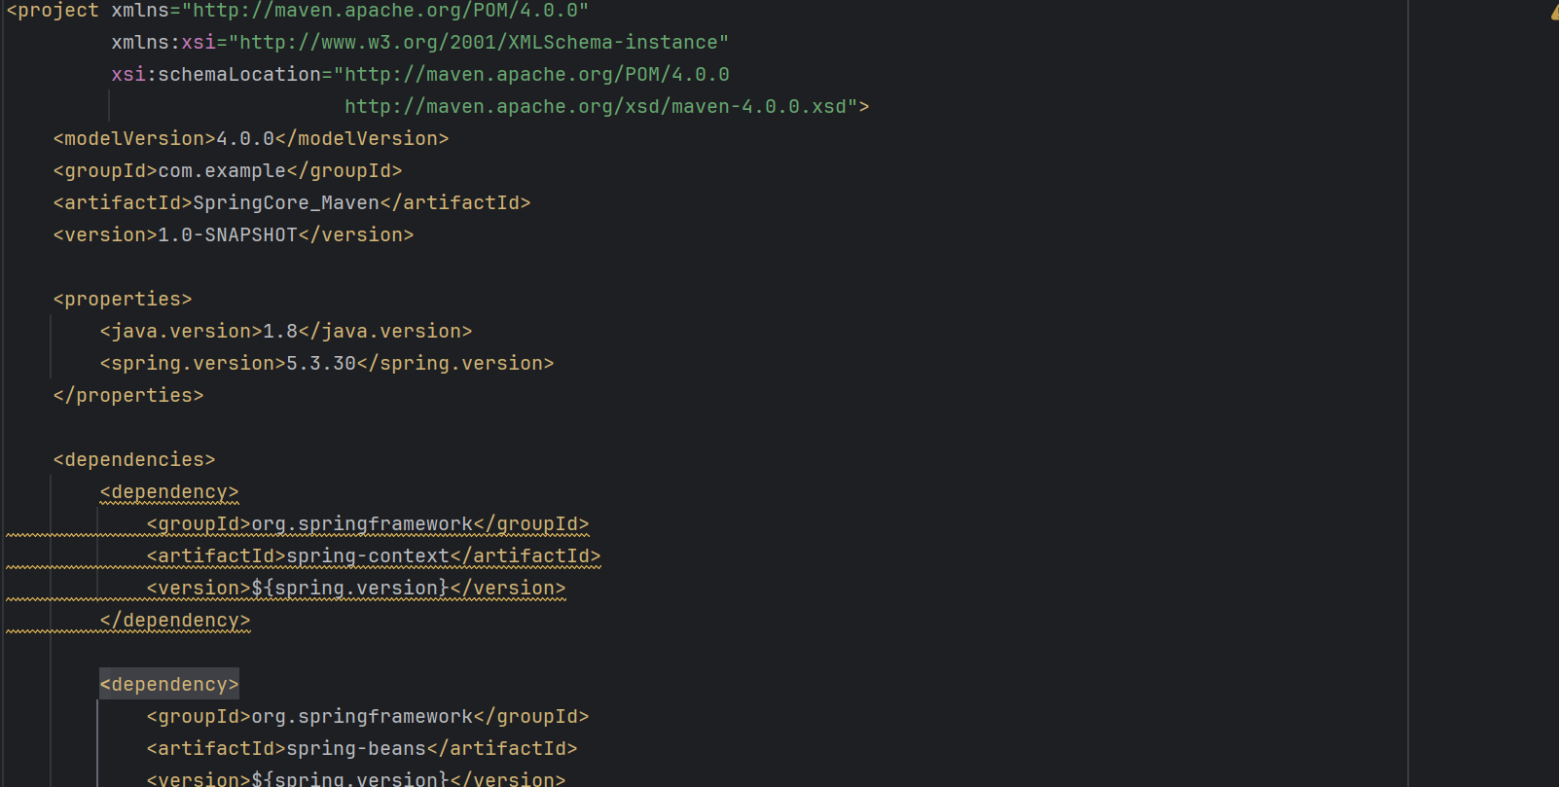

Exercise 2: Injecting Dependencies

package com.example;  
App.java->  
import org.springframework.context.ApplicationContext;  
import org.springframework.context.support.ClassPathXmlApplicationContext;  
  
public class App {  
 public static void main(String[] args) {  
 ApplicationContext context = new ClassPathXmlApplicationContext("beans.xml");  
 HelloWorld hello = (HelloWorld) context.getBean("hello");  
 hello.sayHello();  
 }  
}

pom.xml->

<project xmlns="http://maven.apache.org/POM/4.0.0"  
 xmlns:xsi="http://www.w3.org/2001/XMLSchema-instance"  
 xsi:schemaLocation="http://maven.apache.org/POM/4.0.0  
 http://maven.apache.org/xsd/maven-4.0.0.xsd">  
 <modelVersion>4.0.0</modelVersion>  
 <groupId>com.example</groupId>  
 <artifactId>SpringCore_Maven</artifactId>  
 <version>1.0-SNAPSHOT</version>  
  
 <properties>  
 <java.version>1.8</java.version>  
 <spring.version>5.3.30</spring.version>  
 </properties>  
  
 <dependencies>  
 <dependency>  
 <groupId>org.springframework</groupId>  
 <artifactId>spring-context</artifactId>  
 <version>${spring.version}</version>  
 </dependency>  
  
 <dependency>  
 <groupId>org.springframework</groupId>  
 <artifactId>spring-beans</artifactId>  
 <version>${spring.version}</version>  
 </dependency>  
  
 <dependency>  
 <groupId>org.springframework</groupId>  
 <artifactId>spring-core</artifactId>  
 <version>${spring.version}</version>  
 </dependency>  
  
 <dependency>  
 <groupId>org.springframework</groupId>  
 <artifactId>spring-expression</artifactId>  
 <version>${spring.version}</version>  
 </dependency>  
 </dependencies>  
</project>

package com.example;  
  
public class MessageService {  
 public String getMessage() {  
 return "Dependency Injected "; 🡪 Output   
 }  
}

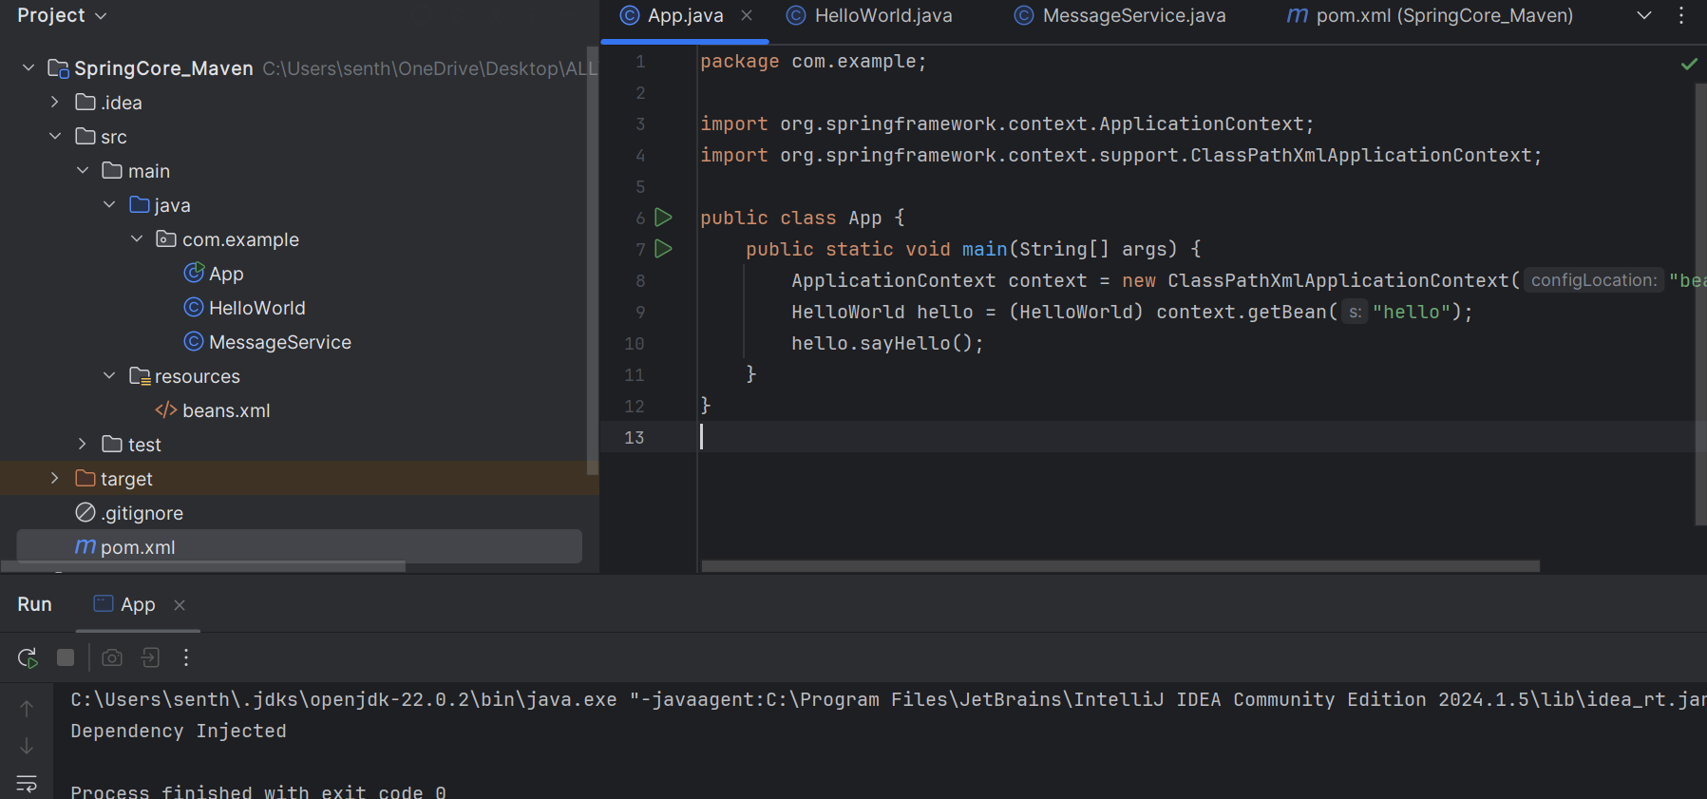

Exercise 3: Creating a Maven project

(Same pom.xml from exercise 1 and 2)

Bean configurations:

<beans xmlns="http://www.springframework.org/schema/beans"  
 xmlns:xsi="http://www.w3.org/2001/XMLSchema-instance"  
 xsi:schemaLocation="http://www.springframework.org/schema/beans   
 http://www.springframework.org/schema/beans/spring-beans.xsd">  
  
 <bean id="messageService" class="com.example.MessageService"/>  
 <bean id="hello" class="com.example.HelloWorld">  
 <property name="service" ref="messageService"/>  
 </bean>  
</beans>

